**Scale Focus Game Project**

**The Bletchey code breakers**



|  |  |
| --- | --- |
| **Made by:** | **Roles:** |
| Hristo Hristov  Email: [HSHristov18@codingburgas.bg](mailto:HSHristov18@codingburgas.bg) | Scrum Trainer |
| Kiril Dimov  Email: [KHDimov18@codingburgas.bg](mailto:KHDimov18@codingburgas.bg) | Quality Engineer, Code Checker |
| Teodor Smolev  Email: [TFSmolev18@codingburgas.bg](mailto:TFSmolev18@codingburgas.bg) | Developer Back-End |
| Kristian Lalev  Email: [KALalev18@codingburgas.bg](mailto:KALalev18@codingburgas.bg) | Developer Front-End, Documentation, Presentation |

# Description of the project

Our aim is to implement a game where you will guess the coordinates of a German battleship. The Germans place a combination of 4 random numbers in the range between 0 and 7, indicating the coordinates of their battleships. You should guess the coordinates within 13 tries. No second chances! The game will allow two players to play against each other and to play versus the computer.

# Diagram of the project

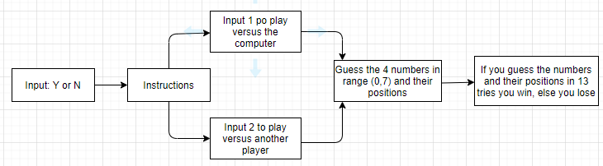

# The functions and how they work

|  |  |  |
| --- | --- | --- |
| **Functions** | **Description of the function** | **Return value of the function** |
| void initialize() | It generates a random number. | This function doesn’t return value because it is of type void. |
| int generateRandomNumberInRange() | This function generates random numbers in range from 0 to 7. | Integer because the function is type of int. |
| vector<int> generateDistinctRandomNumbersInRange() | If you miss some number, it gives you to insert different number between the range. | Returns a pointer to vector in the range. |
| int guessedNumbers() | If the numbers that you type are correct, you should guess only positions on that numbers. | Integer because the function is type of int. |
| int guessedNumbersAndPositions() | if you got to there and you guessed the positions on the numbers, you win the game. | Integer because the function is type of int. |
| vector<int> generateRandomNumbersInRange() | If the desired size is more than the result one, the number should push back and to generate new number in the range | Returns a pointer to vector in the range. |
| vector <int> enterPlayerNumbers() | You choose from the 2 tasks in our game (they can be more in the future). And the function checks if the numbers is in the range. | Returns a pointer to vector in the range. |
| void playTask() | The function that allows you to play our tasks in the game. | This function doesn’t return value because it is of type void. |
| Int main() | The menu of the game is there, the instruction and the tasks and levels in the game. In short, all the things in the game. | It returns your result after the game is done by integer way. |